Note: Include this page only when adding / amending / deleting a document. If using this document as a record, this Revision History page can be omitted.

REVISION HISTORY

Revision no | Date | Description of Changes | Reason for Revision | Revised by | Approved by
1 | 29 Nov 12 | - Add revision history page  - Add creation/update of subscription renewal schedule | - Recommendation from Stage 2 audit  - Q4 2012 IQA OFI | CMRojas
2 | Apr. 8, 2016 | Added disclaimer when printing the document | For document control | RCGanal | ARAlacar
TM-BR-MG- 11 Rev02, 10302015

- Objective
To ensure that the IT Subscriptions being used by the company are up to date and that steps are taken to renew these subscriptions before they expire.
- Scope
This procedure defines the action and responsibilities of the staff of the IT unit to ensure that that IT subscription requirements of the company are met. This includes activities from the time a subscription request is received until the time the subscription is acknowledged by the vendor as received/renewed.

- Definition of Terms
IT Subscription | Any commercial software licence or partnership that is provided by a third party supplier and for which usage or membership is paid for and /or renewed periodically. This may include software licences and membership is such organizations as Oracle and Microsoft
Software Documentation | Any documentation that comes with the software when it is purchased. This includes user manuals, End User Licence Agreements, Licence Certificates, Certificates of Ownership, etc.

- Procedure Details
RESPONSIBLE | ACTIVITY | INTERFACE
IT Head  Accounts Payable Accountant  Technical Support Staff  IT Head | 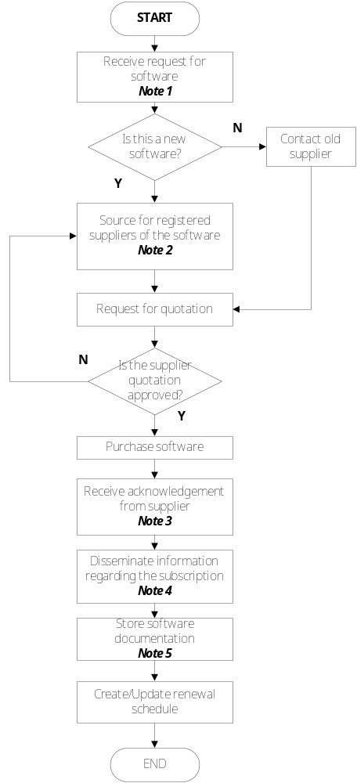 | Requesting party  Software supplier  ExeCom  Finance Head  Procedure for Purchasing  Requesting party  Masterlist of Externally Generated Documents  IT Subscription Renewal Schedule
Note:
- Request for subscription may come as a request for new software or IT subscription, as renewal reminder from an existing licenced supplier, or as scheduled by the company.
- Some subscriptions have only one supplier, e.g. membership in the Oracle Partner Network or in Microsoft. This step may not be necessary.
- Supplier acknowledgements may come in the form of CDs of the updated software or downloadable forms thereof with product keys provided, access to partner and community portals, vouchers for freebies, etc.
- The requesting party and other interested parties should be informed that the subscription is already available. They can informed via an email blast and/or a training session regarding the subscription. If installation of the IT subscription is necessary, the Tech support staff will be in charge of studying the user manuals and installing them in the required machines.
- Receipts/invoices from supplier will be kept by the Finance unit. User Manuals and other documentation will be registered as externally generated document.

- References
• Master list of Externally Generated Documents
- Quality Records
- PO Requisition – c/o Finance Services
- Varied software documentation
- IT Subscription Renewal Schedule

